Chapter 3

# Try It Yourself: Explore a Line Chart

## Excel Instructions

1. Open the child_mortality_long.csv dataset in Excel.
2. Filter the data.
   1. Highlight the country column (Column A) and year column (Column B).
   2. In the Excel ribbon, under the Home tab, navigate to Sort & Filter→Filter. A small arrow will appear on the right-hand side of the column header in Columns A and B.
   3. Filter to show only observations where country is United States.
      1. Click the arrow in the column header in Column A.
      2. Deselect the box next to Select All.
      3. Select the box next to United States. Click OK.
   4. Filter to show only observations where year is between 1880 and 2020.
      1. Click the arrow in the column header in Column B.
      2. Select Number Filters → Between…
      3. In the top box type 1880.
      4. In the bottom box type 2020.
3. Insert the line chart.
   1. Highlight the exact cells for child_mortality (Columns C1 to C56209).
   2. In the Excel ribbon, go to the Insert tab.
   3. Click the Line Chart icon under the group of Charts.
   4. Choose line chart.

1. Add year to the line chart.
   1. Right-click inside the line chart.
   2. Choose Select Data…
   3. Click the Add button

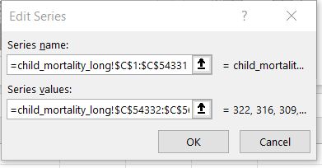

* 1. Click OK
  2. Click Edit in the far right panel.

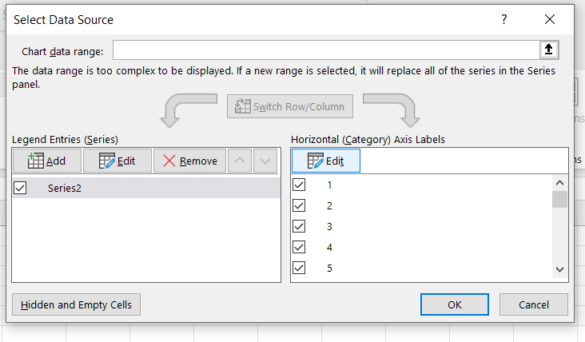

* 1. Click the up arrow 
  2. Select Cells B1 through B56209
  3. Click the down-arrow button to save.

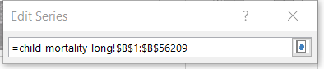

* 1. Click OK
  2. Click OK